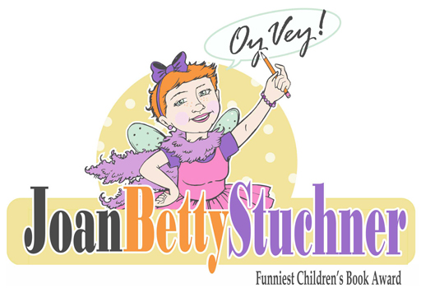

Submission Form

Book Information:
Title of Book:
Author:
Illustrator:
Publisher:
Year Published:

Publisher Contact Information:
Name:
Email: Phone:

Author Contact Information:
Name:
Email: Phone:

Illustrator Contact Information (if illustrations comprise 50% or more of the content):
Name:
Email: Phone:

Payment: $30 per title

o I have paid online via PayPal
o I have enclosed a cheque made out to “JBS Oy Vey Award”
o I have paid via E-transfer to jbs.oyvey.award@gmail.com (OyVey Award)

Please send completed form, payment (if paying by cheque)
and 3 COPIES of each book to:

The Joan Betty Stuchner Oy Vey Funniest Children’s Book Award
6637 Emerson Street, Burnaby BC V5E 1W5

